Playlist for Life Spotify Playlist Maker
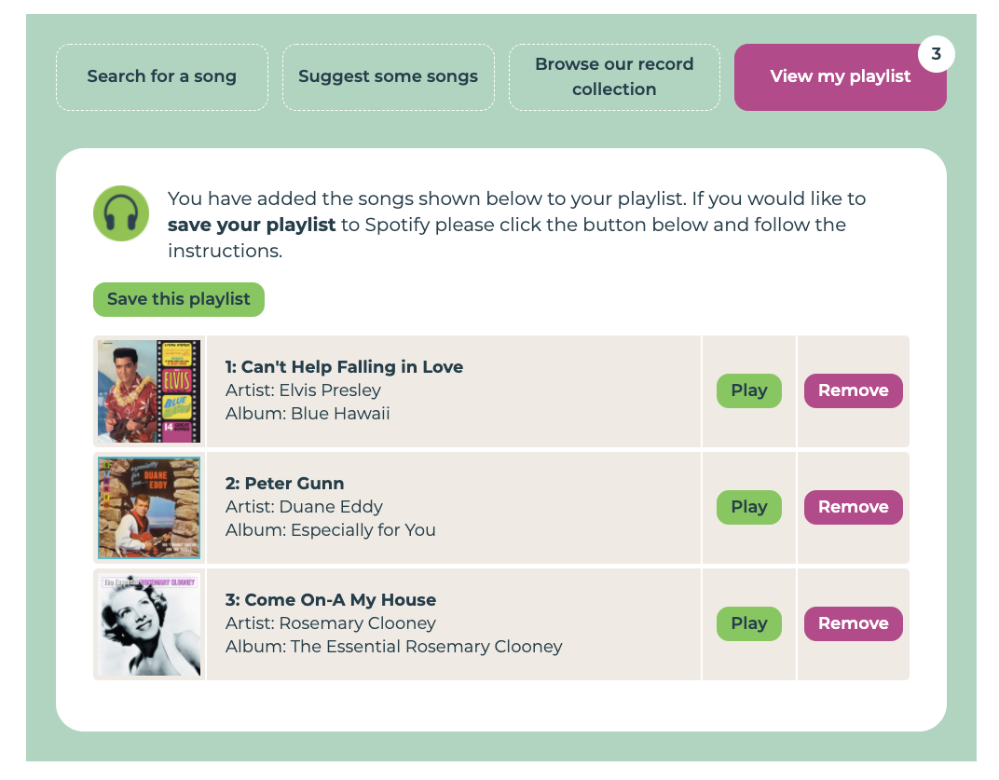
This guide explains the purpose of the Playlist for Life Spotify Playlist Maker and how to use it.

Our playlist maker is designed to help you to find music you like and make a playlist on Spotify easily.

We have tried to make it a simple to use as possible.

What is Spotify?
Spotify is an online music library that has millions of songs. If you like a particular song it’s probably available on Spotify. And if you have a Spotify account you can listen to any song in the Spotify library whenever you like. It’s like having every song ever recorded in your pocket. You simply type a song into Spotify and press play to hear it.

You can also create a playlist of your favourite songs on Spotify so you can find them easily. In fact, you can create multiple playlists. For example, you could make a playlist of songs that cheer you up or a playlist of songs for dancing or a playlist of songs that remind you of a particular person.

To use Spotify you have to create an account. Spotify offers free accounts and paid accounts. The main difference is that the free account will play adverts between songs.

So why is this playlist maker needed?
Spotify is very powerful. But some people with dementia have told us they find Spotify difficult to get started with. They tell us that the Spotify app can seem complicated or difficult to read. And some people don’t want to set up an account until they’ve seen it in action and know it will be helpful. So we decided to make our playlist maker to help you get started. It can help you find music that you might like and create your first Spotify playlist. Once you’ve created your playlist we can email you instructions about how to set up an account and what to do next.

What do I need to use the playlist maker?
To use the playlist maker you will need a computer or a tablet or a smartphone and access to the internet. To create your playlist you will need an email address so that we can email it to you.

How do I get started?
To get started simply open up your internet browser and go to https://www.playlistforlife.org.uk/make-a-spotify-playlist

There are some simple instructions to tell you how to get started. When you are ready to begin finding some songs click the button labelled ‘Get Started’. If you want to see the instructions again then click or tap the button labelled Help in the top right.

How to find songs
There are three ways to find a song using the playlist maker.

- Search by the name of a song or a singer or band you like
- Allow us to suggest some songs based on your year of birth
- Browse our ‘record collections’ – lists of songs sorted into different categories.

You access each of those options using the menu buttons at the top of the playlist maker.

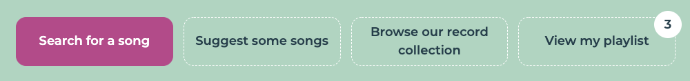

We will explain each of the options in turn.

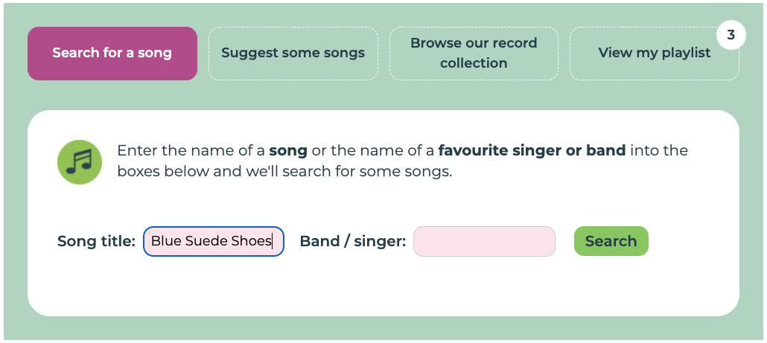
- Search by name
Click or tap the button labelled Search for a song near the top of the screen. Then type the name of a song into the box labelled Song title and / or type the name of a singer or band into the box labelled Band / singer. When you are ready, click or tap on the button labelled Search.

For example, if you wanted to different versions of the song Blue Suede Shoes you would type ‘Blue Suede Shoes’ into the Song Title box.
If you wanted to find various songs by Elvis Presley you would type ‘Elvis Presley’ into the Band / Singer box.
If you wanted to only search for Elvis Presley’s version of Blue Suede Shoes you would type ‘Blue Suede Shoes’ into the Song title box and ‘Elvis Presley’ into the Band / singer box.

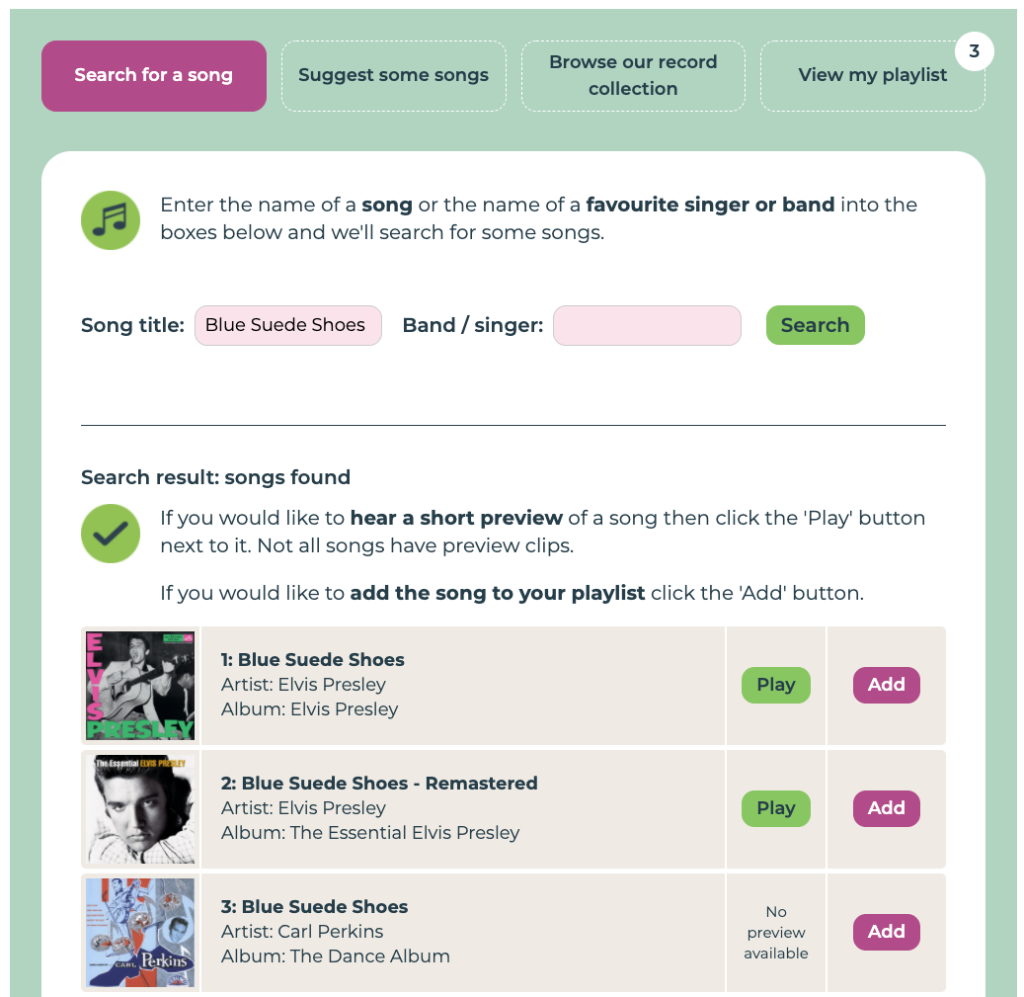
A list of songs should appear below. Each row contains a different song. The song title will be shown along with the name of the band / singer who performs it and the album it is from. There will be an image of the album cover.

For some songs you can hear a short clip of the song to make sure it’s the one you want. To hear the clip click or tap the button labelled Play beside the song name. Not all songs have a preview clip because some artists or record companies have decided not to provide one. Unfortunately, that is beyond our control.

If you want to see what other songs are on a particular album you can click or tap the image of the album cover.

When find a song you want to add to you playlist just click the purple button labelled Add.

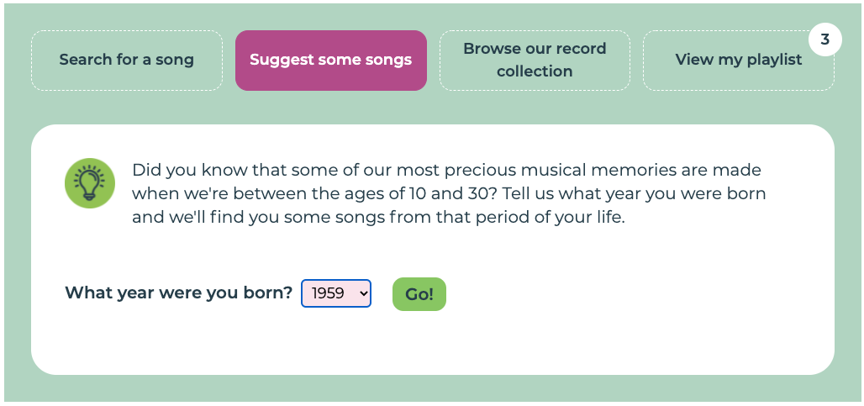
- Use our song suggester
If you would like us to suggest some songs that you may like then use our Song Suggester. The Song suggester works by choosing some songs from when you were young. Research shows that songs from our youth are more powerful for us.

To find your suggestions click or tap the button labelled Song suggester near the top of the screen.

Then click or tap on the year next to the question ‘What year were you born?’. Select your year of birth then click or tap on the button labelled Go!
A list of songs should appear below. Each row contains a different song. The song title will be shown along with the name of the band / singer who performs it and the album it is from. There will be an image of the album cover.

For some songs you can hear a short clip of the song to make sure it’s the one you want. To hear the clip click or tap the button labelled Play beside the song name. Not all songs have a preview clip because some artists or record companies have decided not to provide one. Unfortunately, that is beyond our control.

If you want to see what other songs are on a particular album you can click or tap the image of the album cover.

When find a song you want to add to you playlist just click the purple button labelled Add.

Every time you click or tap on the Go! button different songs will appear. We choose popular songs from the years you were around 10 to 30 years old. But we always add some random songs from those years too. So if you don’t see anything you like the first time just try again and hopefully there will be a song you do like next time!

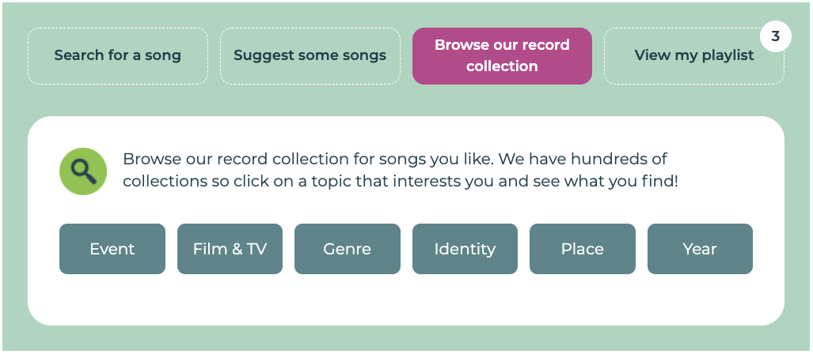
- Browse our ‘record collections’
We have created hundreds of songs collections to help you find your favourite tunes. We call these our ‘record collections’ because we sort them by categories just like you might with a record collection.

Our collections categories are:

- Event: these are songs that were played at a particular event such as the Woodstock Festival.
- Film & TV: these are songs that were used in particular films or TV shows. Lots of people have told us they love hearing the TV theme tunes from when they were young!
- Genre: these are lists of different types of music. We’ve got Rock n’ Roll, Skiffle, Jazz, Punk, Classical and lots more!
- Identity: these are tunes that relate to things that are important to different groups of people. For example, music associated with different religions or political groups.
- Place: lots of countries and cities have songs associated with them. This category lists those. Whether you want to find songs from Scotland, London or Cuba you will find them here!
- Year: these are songs that came out or were popular in a particular year. For example, the top songs of 1934 or 1991. These are the same songs listed in our 100 Years Book so if you use that you can easily find the songs it lists. We also have lists with the top songs of a particular decade.

To find a particular list just click on the topic buttons until a list appears.

Each row in a list contains a different song. The song title will be shown along with the name of the band / singer who performs it and the album it is from. There will be an image of the album cover.
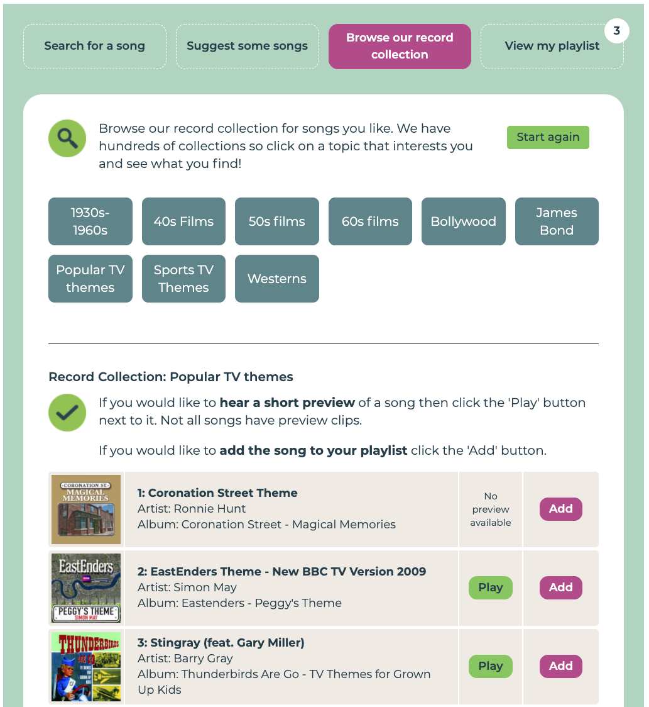
For some songs you can hear a short clip of the song to make sure it’s the one you want. To hear the clip click or tap the button labelled Play beside the song name. Not all songs have a preview clip because some artists or record companies have decided not to provide one. Unfortunately, that is beyond our control.
If you want to see what other songs are on a particular album you can click or tap the image of the album cover.
When find a song you want to add to you playlist just click the purple button labelled Add.

To start again and look for a different list click or tap the button labelled Start again.

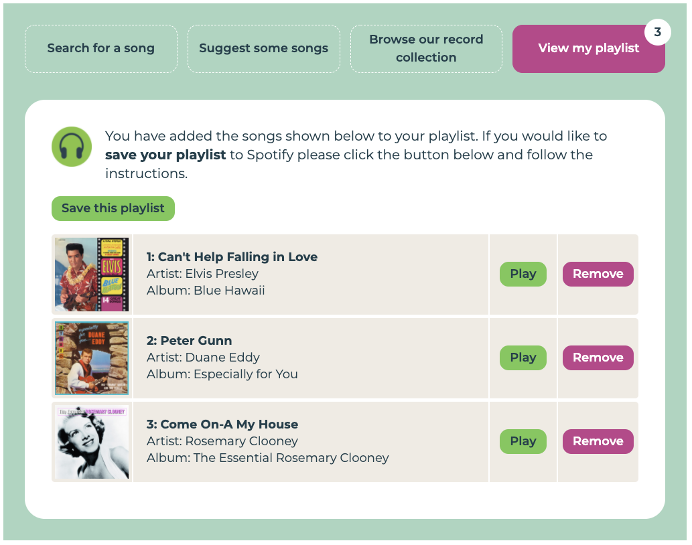
How to view your playlist
You can view your playlist at any time by clicking or tapping the button labelled View my playlist near the top of the screen.

Once you start adding songs to the playlist that button will display a little number in the top right to show you how many songs you currently have on your playlist.

Each row in the list is a different song on your playlist. You can listen to a short clip of the song by clicking or tapping the play button in its row. Unfortunately, not all songs have clips.

If you would like to remove a song from your playlist then click or tap the remove button in its row. If you have added the song accidentally or you just have decided you do not want it on your playlist just click this button to remove it.

Once you are ready to save your playlist click or tap the Save this playlist button.

Saving your playlist
When you are ready to save your playlist click or tap on the View my playlist button near the top of the screen then click or tap the Save this playlist button.

There are two ways to save your playlist.

- If you already have a Spotify account we can save the playlist into your own Spotify account.
- If you do not have a Spotify account we will create your playlist in our own Spotify account then send you details of how to access it. You can also choose this option even if you do have a Spotify account.

To choose the option you prefer click or tap on the button labelled Choose this option underneath your preferred option. The screen will show you instructions for your preferred option.

1. If you already have a Spotify account
A form will appear on the screen. It asks for:
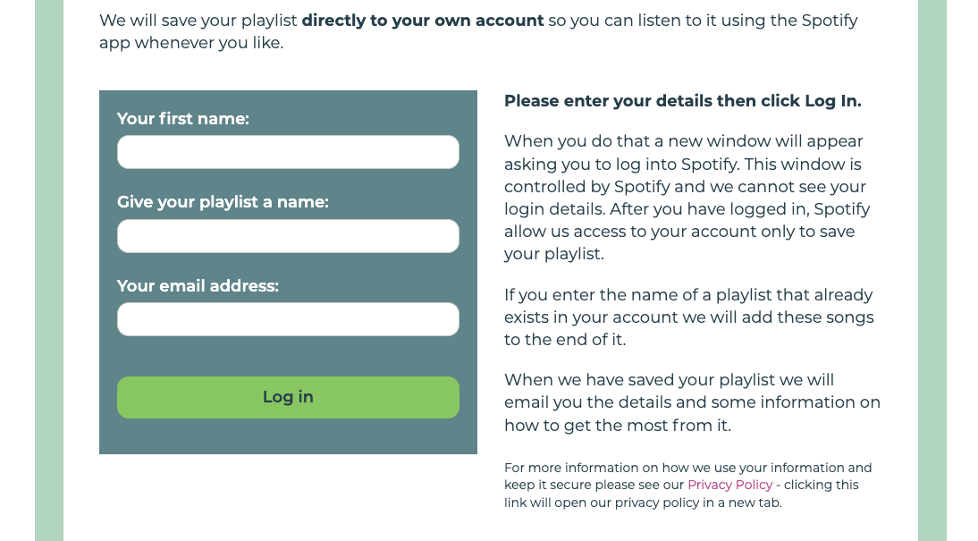
Your first name: we ask for this so that we can address you correctly in the email we send you.
A name for your playlist: this is what your playlist will appear as in your Spotify account. It can be anything you like. If you enter the name of a playlist that already exists in your account we will add these songs to the end of it.

Your email address: we ask for this so that we can email you a link to your saved playlist and some guidance on how to get the best out of it.
After you have typed in those details click or tap on the button labelled Log in.
When you do that a new window will pop up asking you to log into Spotify. Type your Spotify username and password into this window. This window is controlled by Spotify and we cannot see your login details.

After you have logged in, Spotify allows our playlist maker to access your account to save your playlist. Neither the playlist maker or any person can ever see any private information such as your password or your address or your bank details.
Once you have given us access to your account our playlist maker will remember that unless you clear the history on your web browser. If you come back to the playlist maker after some time and save a new playlist Spotify will ask you to confirm our playlist maker’s access to your Spotify account to make sure you are still happy for it to be given access.

If you would like to remove our playlist maker’s access to your account at any time then you can do so from your Spotify account page. Just log into that then tap Apps in the menu on the left, and REMOVE ACCESS next to Playlist for Life playlist maker.

When we have saved your playlist we will email you the details and some information on how to get the most from it.

2. If you do not have a Spotify account
A form will appear on the screen. It asks for:
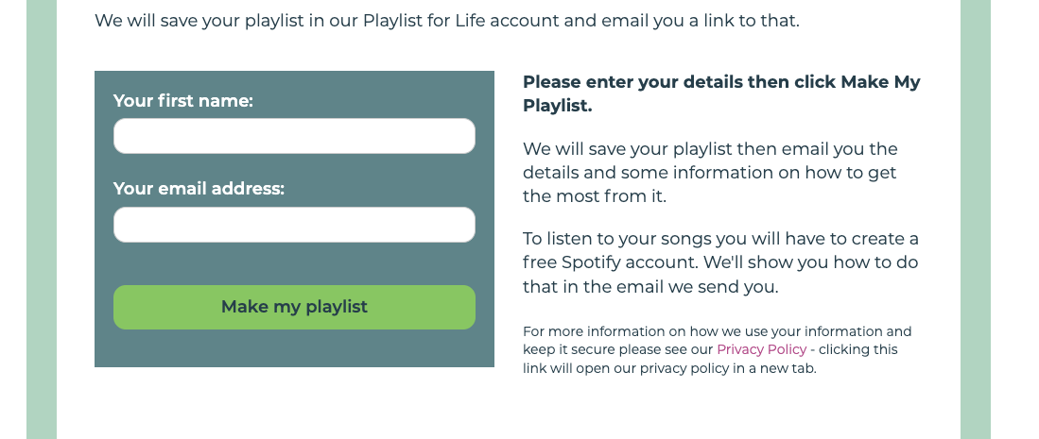
Your first name: we ask for this so that we can address you correctly in the email we send you and because we give your playlist a name that includes your first name. For example, if you are called Joan we will call your playlist “Joan’s Playlist for Life”.

Your email address: we ask for this so that we can email you a link to your saved playlist and some guidance on how to get the best out of it.

After you have typed in those details click or tap on the button labelled Make my playlist.

When we have saved your playlist we will email you a link to it so that you can find it and some information on how to get the most from it.

How do I ask a question about the playlist maker or share an idea?
We would love to hear what you think of the playlist maker. We want it to work for everyone who needs it and we can only improve it if you tell us what you like and what could be better.

We have put together a form that you can use to give us feedback. You can find that here: https://www.playlistforlife.org.uk/survey2/

There will also be a link to that form in the email that we send you with your new playlist.

